华东师范大学 国际学生住宿费退款申请表
Accommodation Fee Refund Application Form
for International Students

为确保退费申请及时准确处理，请用正楷清晰填写。
To ensure timely and accurate processing of your refund application, please write clearly.
学号 Student ID
姓名 Name
学生类别 Student Category
国籍 Nationality
申请退费原因  Reasons for Refund | □退学/Withdrawal  □其他原因/Other Reasons：  申请人签字/Signature of Applicant：  年(Y) 月(M) 日(D)  以下内容无需填写！No need to fill in the blanks below.
国际教育管理中心意见 Comments by Office of International Education
退费金额/Refund Amount：
住宿费/Accommodation fee： 元/RMB

*学生备齐全部材料后，国际教育管理中心才收取，不受理缺件申请。All required documents must be complete before submission. Incomplete applications will not be accepted.
经办人意见：  经办人签字：  日期： |  | 中心领导意见：  领导签字：  日期：

申请附件/Supporting Documents：
1、填写完整的银行账户信息，附银行卡信息单/Completed bank account details, with a copy of bank information sheet.
2、委托书（如需要）/Letter of Authorization (if required).

附件一/Supporting Documents

银行账户信息
Bank Account Details

我认可退费金额将退至以下银行账户:
I acknowledge that the refund amount will be credited to the following bank account.

银行卡用户名/Account Name:
银行卡号/Account No.：
开户行名称/Bank branch：

注/Note：
- 本页面填写完毕后，扫码再次提交银行账户信息。 After completing this form, please scan the QR code to submit your bank account information again.



2、另需提供银行卡信息单。Bank information sheet is also required.

本人签名/Signature：
日期/Date:
银行卡信息单样本
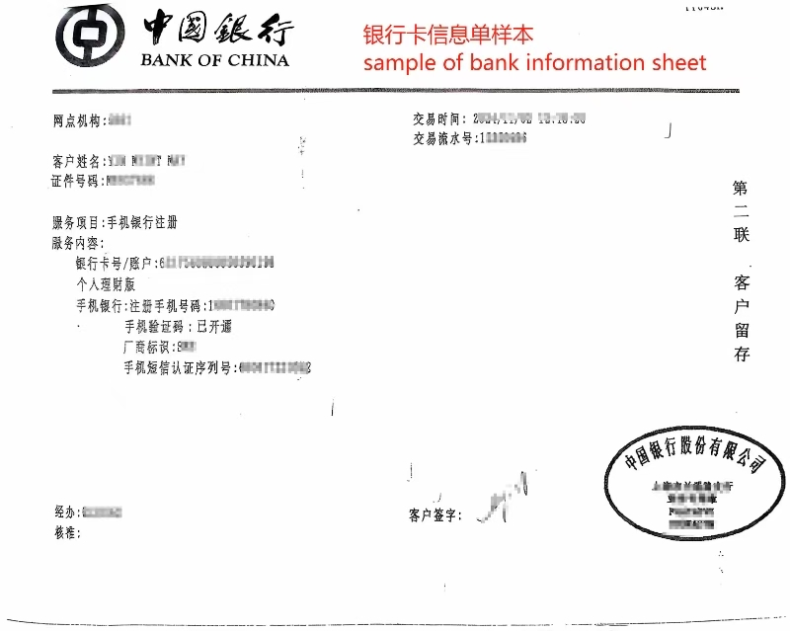
Sample of Bank Information Sheet

附件二/Supporting Documents

委 托 书
委托人姓名： 学号： 护照号：
被委托人姓名： 证件号：

本人是华东师范大学的学生，由于本人不能亲自办理退费相关手续，特委托 作为我的合法代理人，全权代表我办理相关事项，对于委托人在办理上述事项过程中所签署的文件，我均予以认可，并承担相应的法律责任。
我认可退费金额将退至以下银行卡上：
银行卡用户名：
银行卡号：
开户行：

委托人签名：
年 月 日

Letter of Authorization

Consignor Information:
Name: Student ID: Passport No.
Consignee Information:
Name: ID:

I am a student of East China Normal University. Since I cannot go through the refund process in person. I hereby entrust as my consignee to handle the relevant matters on my behalf. I accept the documents signed by the consignee during this process and bear the corresponding legal responsibilities.

Please refund the fee to this account:
Bank Account Name:
Bank Account No. :
Bank Branch:

Signature of Consignor:
Date:

